Lab – 6 – DevOps Docker Containerization on AWS with ECR & ECS

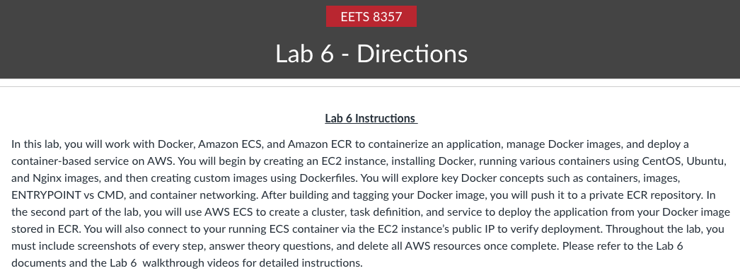
Let us start by defining some important terms and services used in this lab:

Docker:
Docker is an open-source software platform to create, deploy and manage virtualized application containers on a common operating system (OS), with an ecosystem of allied tools. Docker packages, provisions, and runs containers. Container technology is available through the operating system: A container packages the application service or function with all the libraries, configuration files, dependencies, and other necessary parts and parameters to operate.

Containers:
A container is a standard unit of software that packages up code and all its dependencies so that the application runs quickly and reliably from one computing environment to other. Multiple containers can run on the same machine and share the operating system kernel with other containers, each running an isolated process in user space.

Virtual Machine (VM):
We can say VM is an abstraction of physical hardware turning one server into many servers. A hypervisor allows many VMs to run on a single machine and each VM includes a full copy of the OS, apps, binaries, and libraries.

Amazon Elastic Cloud Compute (EC2):
Amazon Elastic Compute Cloud (Amazon EC2) is a web service that provides secure, resizable computing capacity in the cloud. Amazon EC2’s simple web service interface provides you with complete control of your computing resources and lets you run on Amazon’s computing environment.

Amazon Elastic Container Service (ECS):
Amazon Elastic Container Service (Amazon ECS) is a highly scalable, fast, container management service that makes it easy to run, stop, and manage containers on a cluster. Your containers are defined in a task definition that you use to run individual tasks or as a service. You can run your tasks and services on a serverless infrastructure that is managed by AWS Fargate or, for more control over your infrastructure, you can run your tasks and services on a cluster of Amazon EC2 instances that you manage.
Amazon ECS enables you to launch and stop your container-based applications with simple API calls. You can also retrieve the state of your cluster from a centralized service and, for existing users of Amazon EC2, access many familiar Amazon EC2 features.

Amazon Elastic Container Registry (ECR):
Amazon Elastic Container Registry (Amazon ECR) is a managed AWS container image registry service that is secure, scalable, and reliable. Amazon ECR supports private container image repositories with resource-based permissions using AWS IAM so that specific users or Amazon EC2 instances can access repositories and images. Developers can use their preferred CLI to push, pull, and manage Docker images, Open Container Initiative (OCI) images, and OCI-compatible artifacts.

Note: You must submit screenshots for this lab.
Paste screenshots for each step you performed including all data files and Docker files.

Part 1: Deploying Docker container on an EC2 instance and pushing Docker image to ECR.
Perform the Following Steps.

Creating User and Ec2 instances with docker installation.
  - Go to AWS Console and Create a new user named <your-name-Docker> and give them the following permissions:
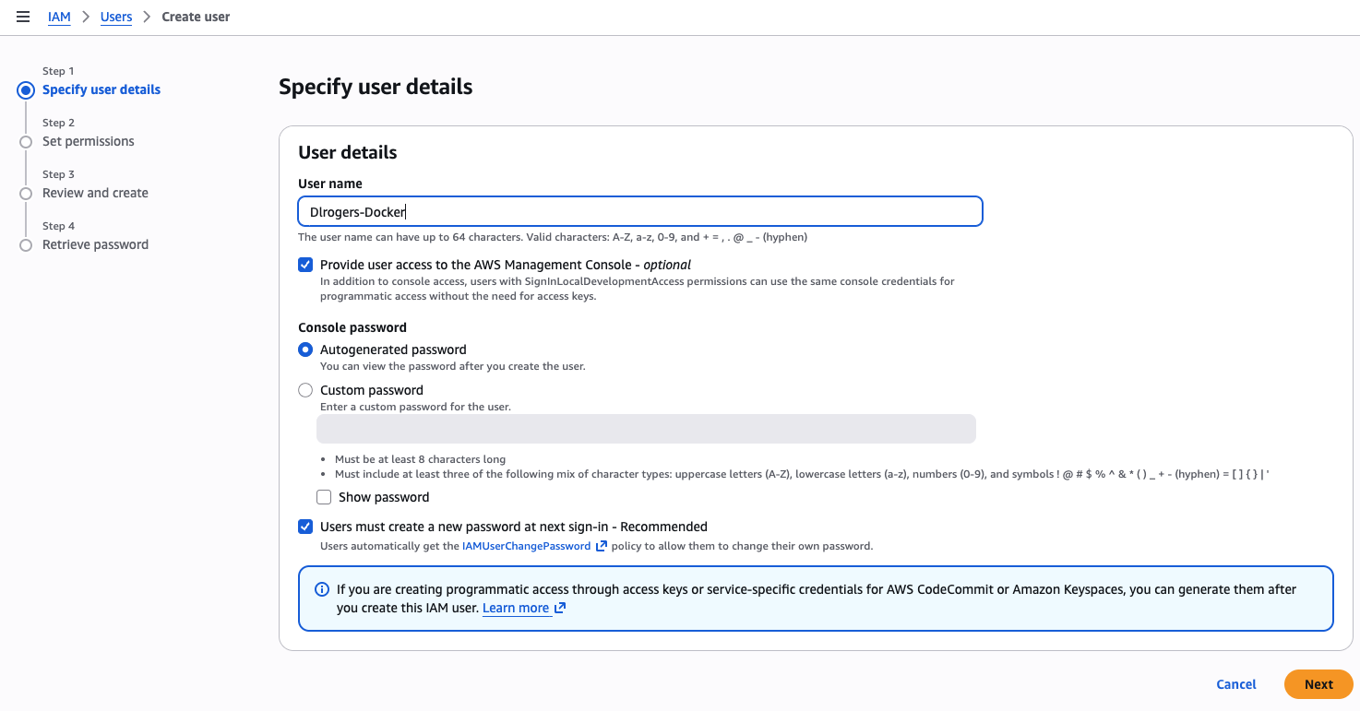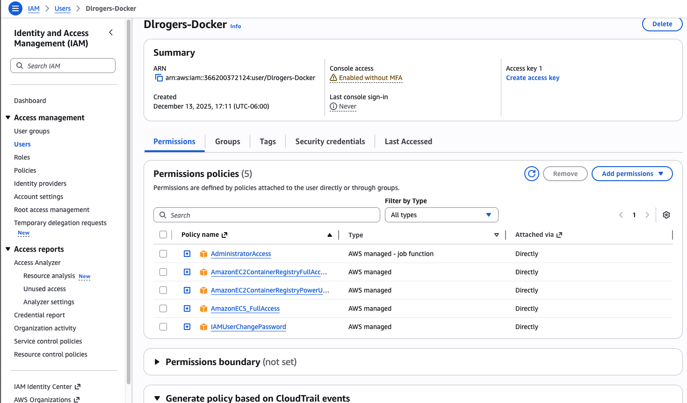

  - Download the CSV file after creating a new IAM user and log back into the console using those credentials
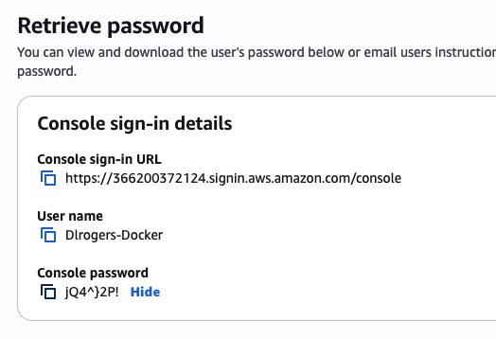
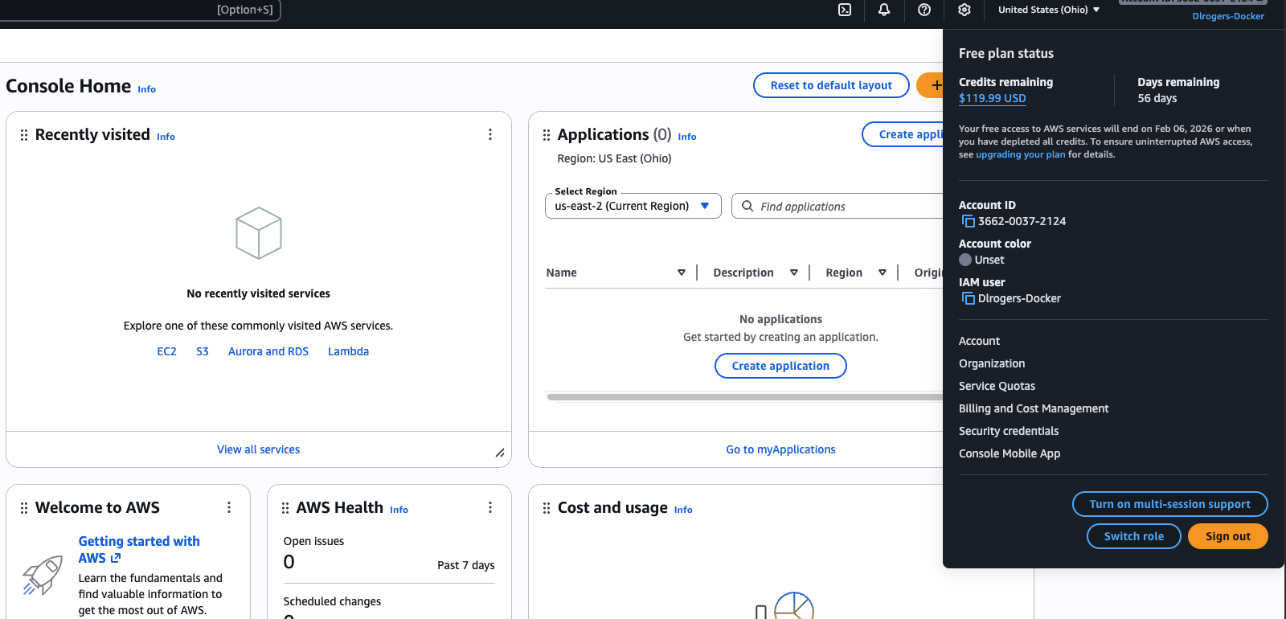
  - Start by creating a new EC2 instance.
Do check the following screenshots for information to be entered and replace them.
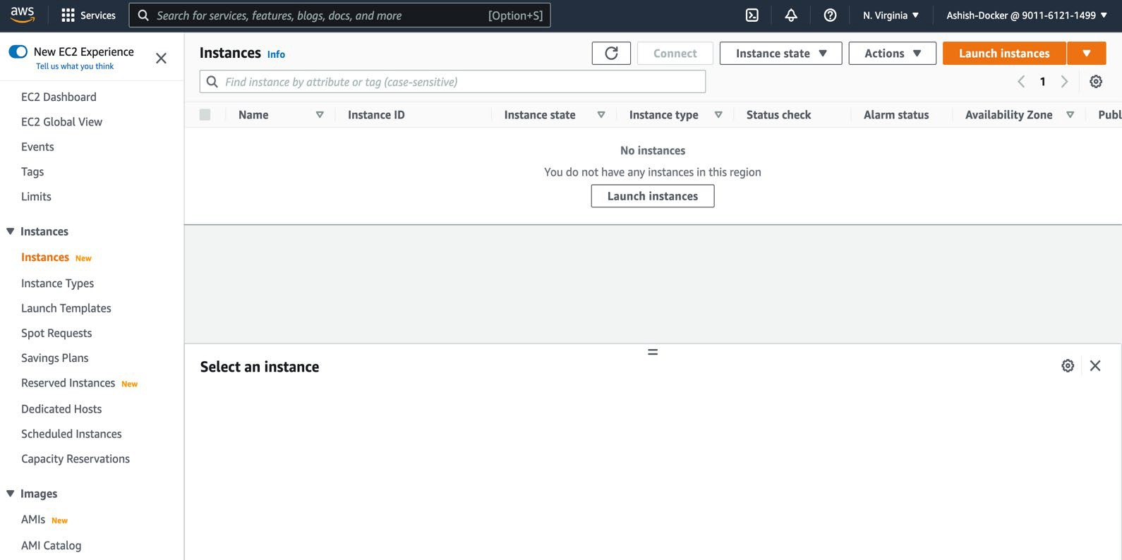

Create a new Key-pair Key, do securely store it on your device.
After launching, wait for the instance to pass health checks. (Add Screenshot)
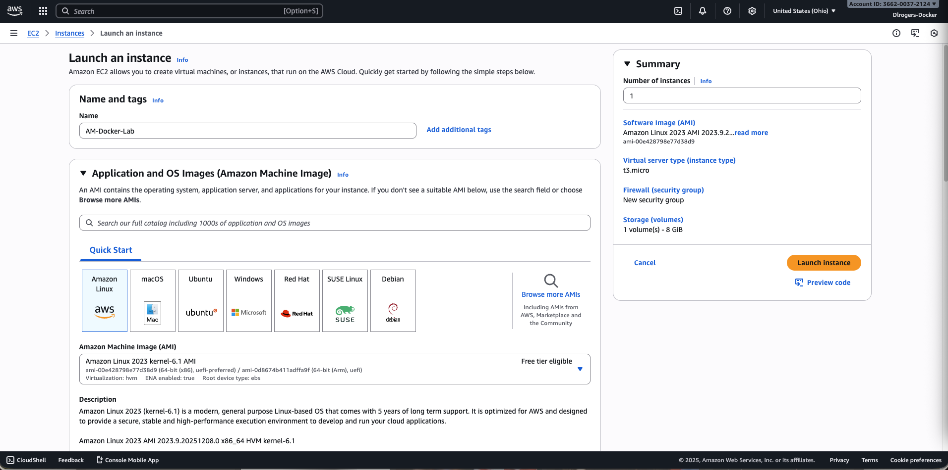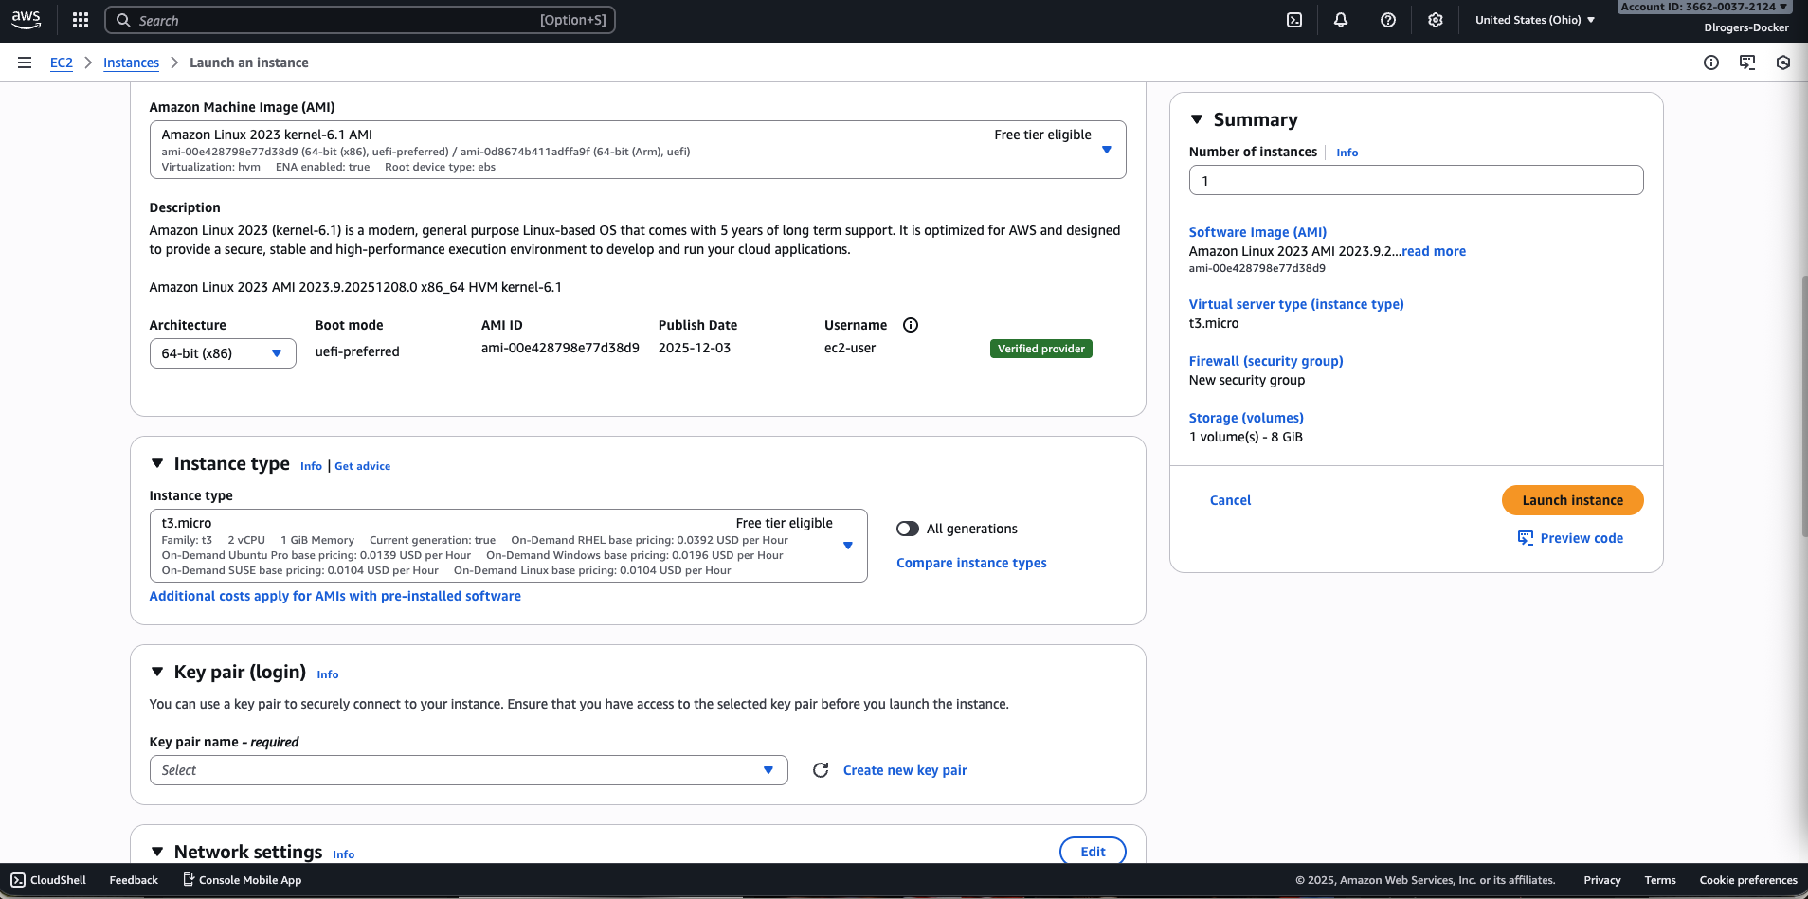

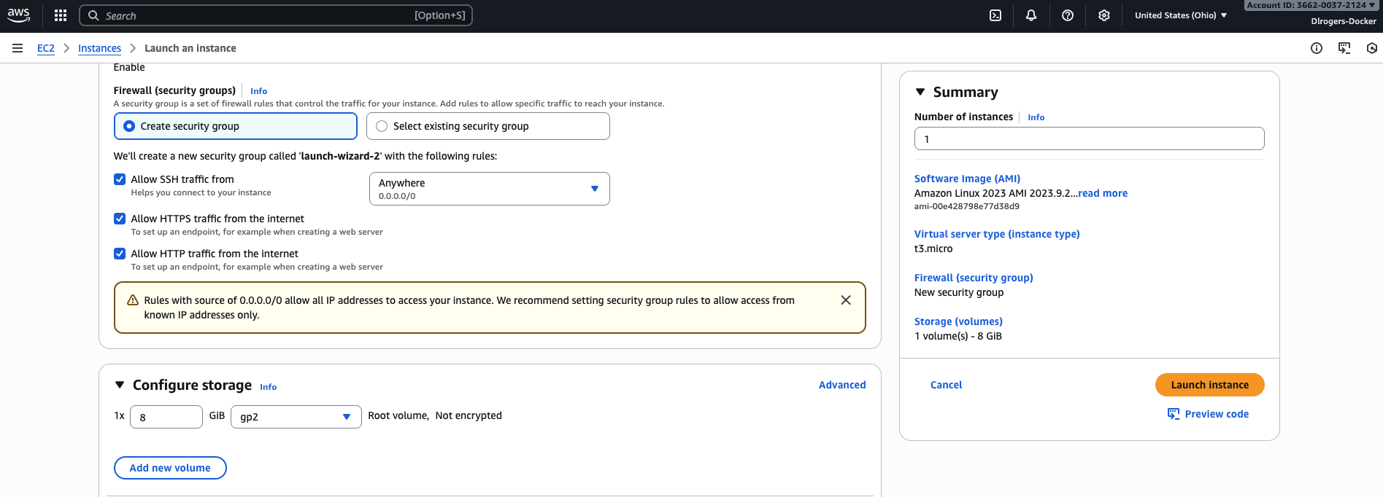
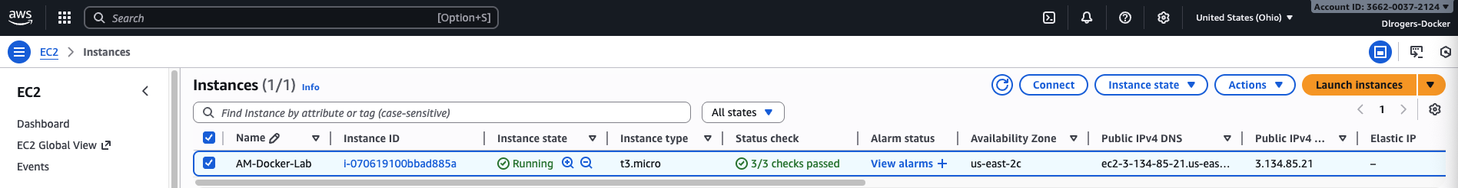

  - Connect to this instance (Add Screenshot)
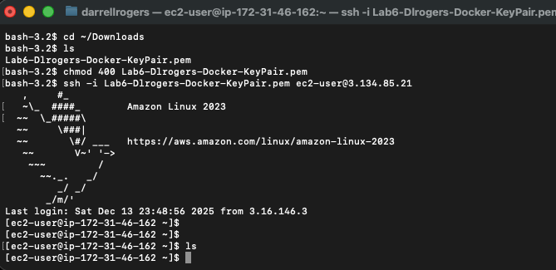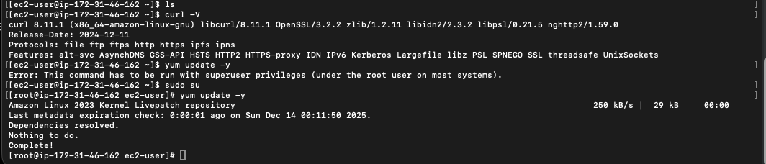
  - Install Docker on this instance and verify:
The docker service by default can be run only by root. If a user needs to use docker, it needs to be added to the docker group.
This can be done by issuing the command ‘usermod -aG docker user-name’.
Add your user to the docker group and verify by issuing command ‘id user-name’.
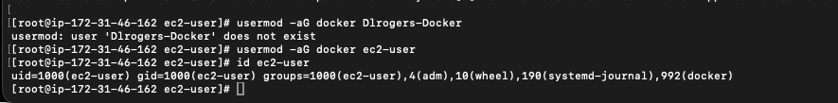
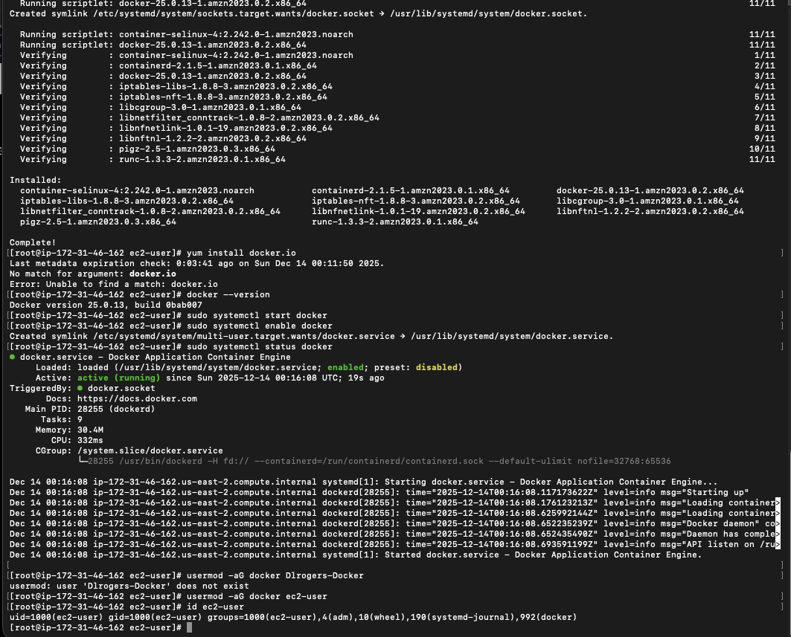
  - Once this is done, reboot the system for the changes to take effect.
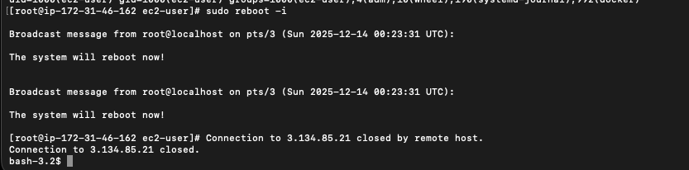
  - Login back into your host and check which version of docker is running.
Issue the command ‘docker info’ to get more detailed information such as several containers running/paused/stopped, root directory, server mode, runtime, logging drivers, etc...

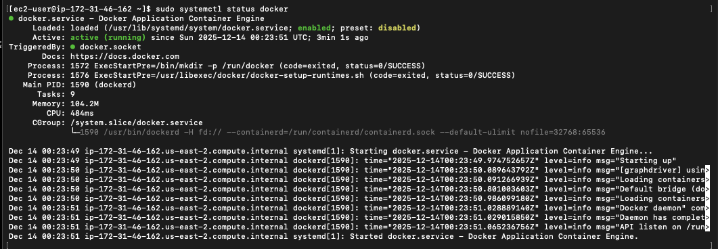

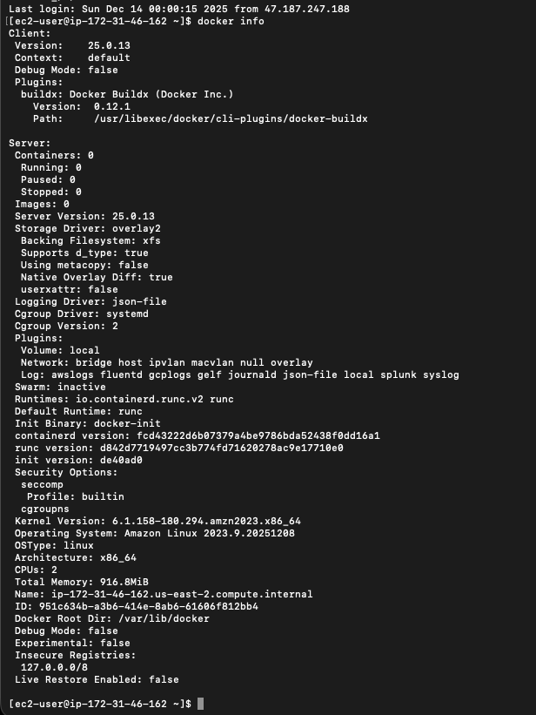

  - Verify that Docker Engine - Edition is installed correctly by verifying its version.
$ docker –version

  - Run a simple container with the help of an image shown.
- $ docker run docker/whalesay cowsay “Hello-yourname…”

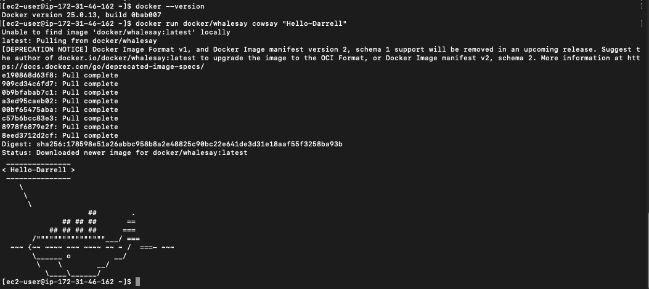

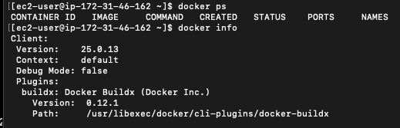

Launching a Docker Container.
  - Pull the centos6 and latest ubuntu image from Docker Hub (repository) & list the currently available images. Use the commands required to complete the above task.
  - To run a centos container using docker, issue ‘docker run centos’
If you check the output carefully, it says that the new image ‘centos:latest’ is downloaded from repository. It means if an image was not available locally, Docker pulled image and created a container out of it. Both tasks are performed with a single command “docker run”.
  - Run two containers based on ubuntu and centos6 images which were pulled before. Make sure that the Ubuntu container has your name.

  - Check all containers created. Are they running? Justify.

    - The containers are not running because their main process (/bin/bash or echo) completed execution.
    - Docker containers run only while their primary process is active.
    - Once the process finishes, the container exits and appears in docker ps -a with status Exited.

  - Deploy a new centos container which should sleep for 1 minute. And check if the container is running or not? Monitor it for a minute by checking its status again and again. What did you observe and why is the container not running?
    - 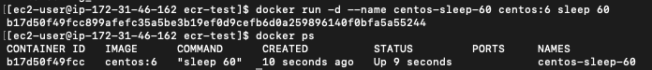
    - 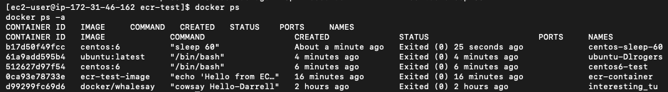
    - The container was running initially because the sleep 60 command was active.
    - After 60 seconds, the sleep command completed execution, causing the container to exit.
    - Docker containers stop when their main process (PID 1) finishes execution, which is why the container is no longer running. 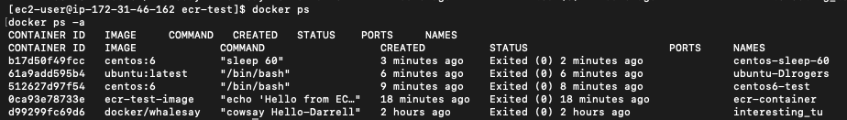

  - Run a new “nginx” container but this time the container should be running and should be seen in ‘docker ps’.
    - 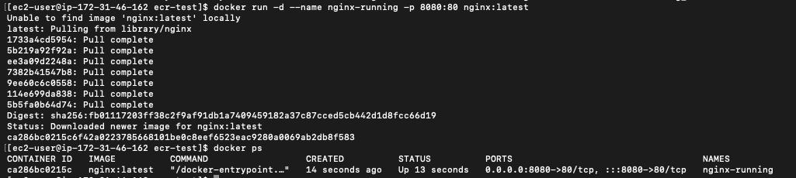
    - The nginx container remains running because nginx executes as a long-running foreground process.
    - Unlike short-lived commands such as echo, sleep, or /bin/bash, nginx continuously listens for incoming requests, which keeps the container in the running state and visible in docker ps.
  - Delete all containers created. - ‘docker rm container-name_OR_ID’
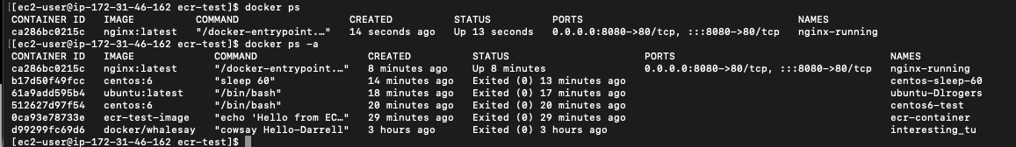
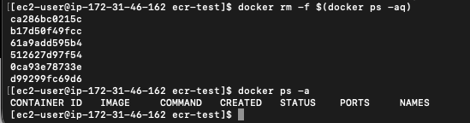
  - Check & Delete all images present on the host. - ‘docker rmi image- name_OR_ID’
    - 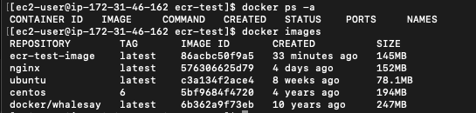
    - 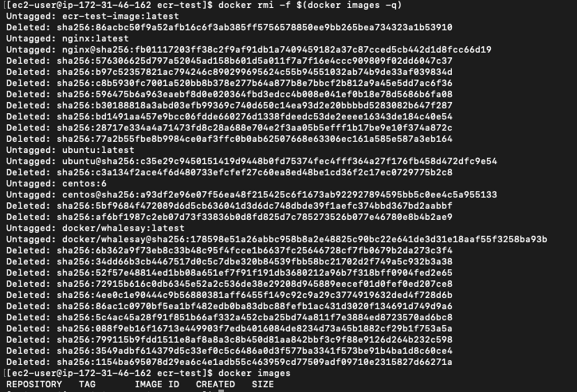
    - All Docker images were removed using the docker rmi command.
    - Removing unused images helps reclaim disk space and ensures a clean Docker environment for subsequent tasks.
  - Create a Dockerfile with a “busybox” image and name it ‘busybox:your-name’. Build Dockerfile to create an image, Using “docker build –t busybox:your-name .” Refer attached screenshot.
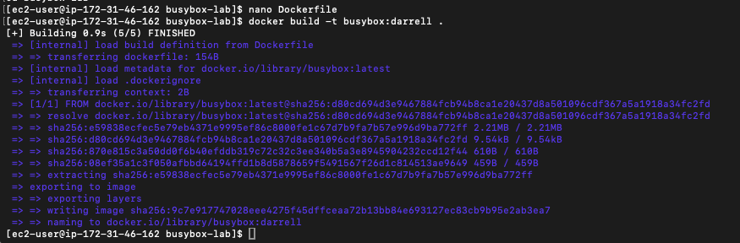
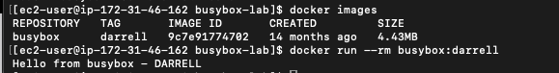

  - In your home directory create a folder named “MyDir” navigate to it and create 2 blank files named – Container1 and Container2.
Then create a Dockerfile with the following specifications.
Start editing the file, the first instruction specifies the base image to be used. Use an ubuntu image
Update image
Install python and nano
Copy both files (Container1 and Container2) to container at location “/opt/source-code/” Add an Entrypoint “sleep” and Command “20”
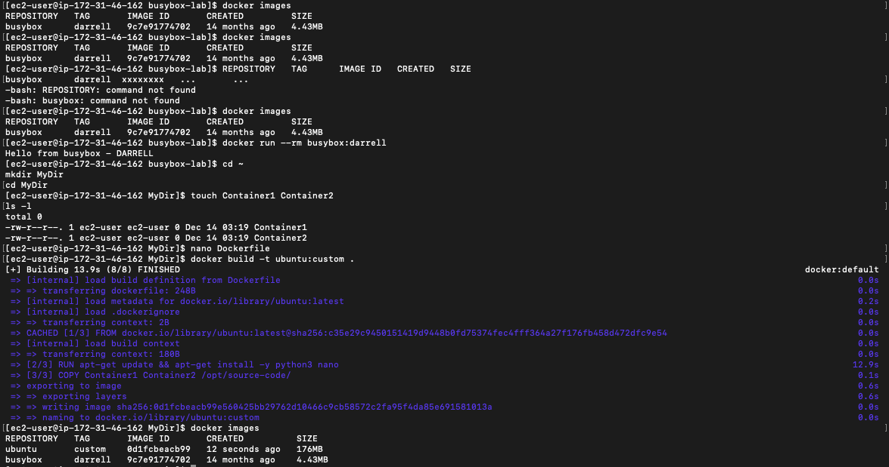
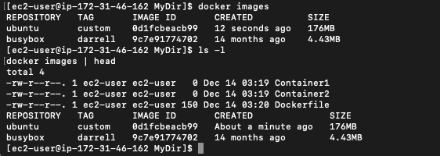
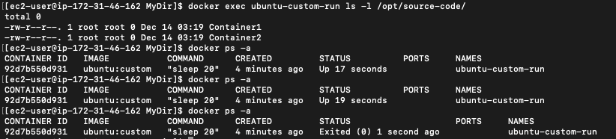
The container initially exited because the Dockerfile uses ENTRYPOINT ["sleep"] and CMD ["20"], so the main process runs only for 20 seconds. docker exec requires the container to be running, therefore the container must be started again (or run with a longer sleep) before checking /opt/source-code/.
- Run a container using an image you created in the above step.
- Now check the contents of the “/opt/source-code/” directory of the container you created in last step. Do this without getting inside the container.
- Write the difference between ENTRYPOINT and CMD instruction.
  - ENTRYPOINT defines the main executable that always runs when the container starts.
  - CMD defines default arguments for ENTRYPOINT (or a default command if ENTRYPOINT is not set).
  - If both are present, CMD provides parameters to ENTRYPOINT.
  - In this lab: ENTRYPOINT runs sleep and CMD sets the default duration to 20.
- Delete all containers created. Check & delete all images present on the host.
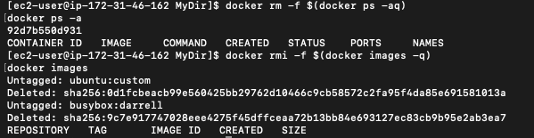
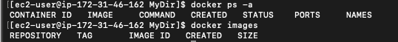

Modifying and creating your Image
  - Get back to your home directory and launch a container based on centos6 image with an interactive terminal attached to it.

  - Once inside the container’s shell, install and enable the following packages.
    - Initscripts
    - Nano
    - Python
    - Httpd
    - iproute
    - Sudo
    - OpenSSH-server
    - telnet
    - enable sshd and httpd service on boot by using command ‘chkconfig sshd on’ and ‘chkconfig httpd on’
    - start sshd and httpd services.

If not able to install the packet in Step 25, perform the following steps. Open file using command - vi /etc/yum.repos.d/CentOS-Base.repo Delete all the file data and copy and paste the following.
[base]
name=CentOS-$releasever - Base baseurl=https://vault.centos.org/6.10/os/$basearch/ gpgcheck=1
gpgkey=file:///etc/pki/rpm-gpg/RPM-GPG-KEY-CentOS- #released updates
[updates]
name=CentOS-$releasever - Updates baseurl=https://vault.centos.org/6.10/updates/$basearch/ gpgcheck=1
gpgkey=file:///etc/pki/rpm-gpg/RPM-GPG-KEY-CentOS-6 [extras]
name=CentOS-$releasever - Extras baseurl=https://vault.centos.org/6.10/extras/$basearch/ gpgcheck=1
gpgkey=file:///etc/pki/rpm-gpg/RPM-GPG-KEY-CentOS-6

  - Once the above packages and services are installed, verify the ssh and http service are running or not.
    - 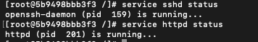
  - Exit out of the container. The container will be stopped.
  - Now create a new image from this container and name it centos6:WEB
    - 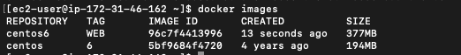
  - Launch a new container using the newly created image in above step. You will notice the new container is already having all packages installed and you just need to enable the services now and check status. Once done, return to Docker host by exiting the container. This is the most important feature of docker which makes it an integral part of CI/CD.
    - 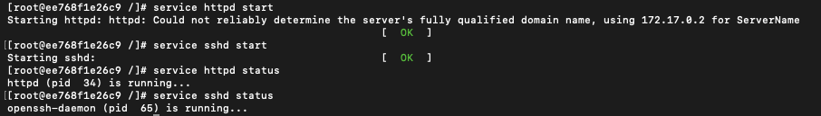

  - Containers we launch on a docker host are running inside the hosted network. Services you enable on them are not available over the network. To expose the services running inside a container, we will have to expose the TCP/UDP port running on a container to local host. Exit the container you launched in the previous step and relaunch it using the following command: docker run -it --yourname="test_web" -p 8080:80 centos:WEB /bin/bash
    - The Apache HTTP service was successfully exposed using Docker port mapping (-p 8080:80).
    - The curl command returned an HTTP response from Apache, confirming that the containerized web service is reachable from the Docker host.
    - The 403 Forbidden response indicates Apache is running and responding, but access is restricted by default configuration, which is expected behavior.

Once the container is launched, start the httpd service and verify the web page from any browser by accessing your docker host’s IP with port 8080. (Example: http://10.44.104.117:8080, assuming 10.44.104.117 is your docker host).
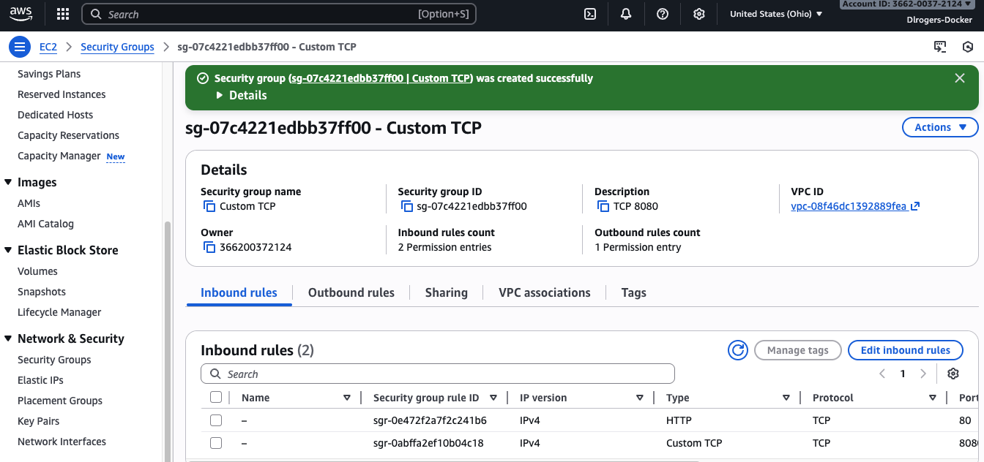

  - Delete all containers created. Check & delete all images present on host.

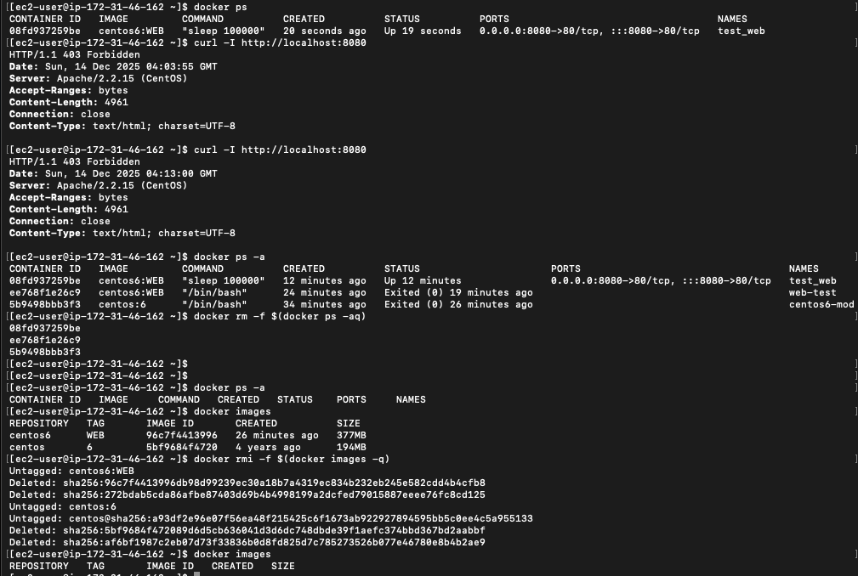

Pushing Images to ECR.
  - Now, on your ec2-instance, write a simple Dockerfile and create an image from it. (Add Screenshot of Dockerfile & Image)
    - 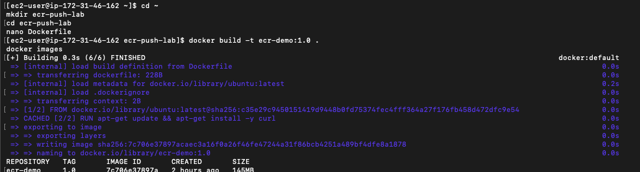
  - Spin up a container from a previously created image and inspect the details of the Docker Container. (Add Screenshot of Output Along with Command Used to Create Container)
    - 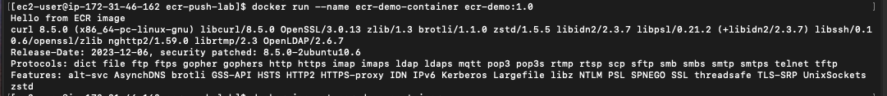
  - Get the following output and explain every part of the command you used to get this. Explain the command you used in the following step.
Command: docker inspect ecr-demo-container
- docker → Docker CLI tool
- inspect → shows low-level configuration details in JSON
- ecr-demo-container → the container name being inspected
What the output contains:
- Container ID, image ID, created time
- Command executed, environment variables
- Network settings (IP, ports), mounts/volumes
- Host config (runtime, log driver), state (running/exited)

  - Theory Questions:
    - Explain what a Dockerfile and Docker image is.
A Dockerfile is a text file containing instructions used to build a Docker image (base image, packages, copy files, run commands).
A Docker image is a read-only template built from a Dockerfile that contains the application and dependencies used to create containers.
    - Explain what is a Docker container.
A Docker container is a running instance of a Docker image. It includes the application process and runs isolated from other containers while sharing the host kernel.

    - Explain ECR and how it is similar to Docker Hub.
Amazon ECR is AWS’s managed container registry for storing Docker images privately and securely using IAM permissions.
It is similar to Docker Hub because both store/publish container images, but ECR is integrated with AWS security, IAM, and ECS.
  - Go back to AWS Console then select Elastic Container Registry and create a repository.
  - Connect your EC2 instance to your previously created repository (add screenshots of each step done to achieve this)
  - Tag and push your previously created image to ECR.
  - Verify whether the image has been pushed successfully.

CONCLUSION: We have successfully created an EC2 instance, created a Docker image and Docker container in it as well as pushed our Docker image.

Part 2: Deploying an application to AWS using Docker, Elastic Container Service (ECS), and Elastic Container Registry (ECR).

Start with your local machine (Any terminal or VM, of your choice)
- Install AWS CLI and Docker.
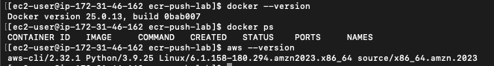
- Create a new directory and navigate into it and check docker status.
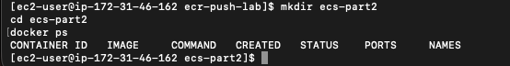

- Write a Dockerfile such that after creating the image and container from it, you get the following output after using curl command. Attach Screenshots of your Dockerfile, image, and container.
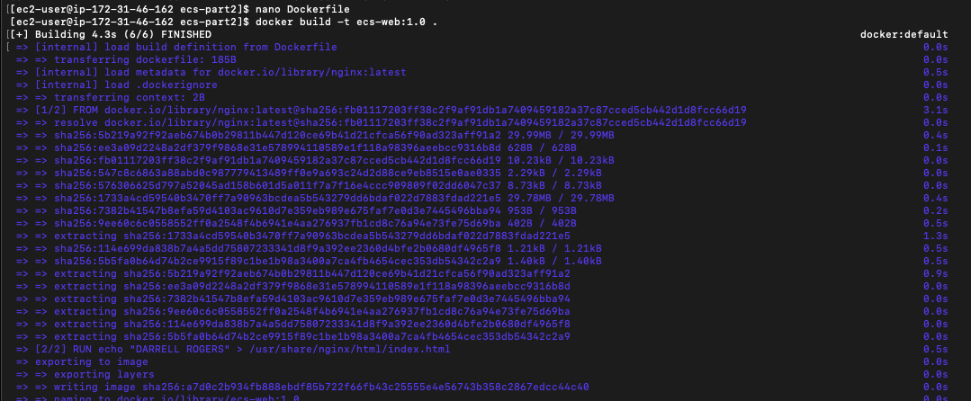
- Connect your local machine to the repository you created previously.

- Tag and push your image to ECR
- Now we will create an ECS cluster. Go to Console and choose Elastic Container Service and follow the following steps:
  - Make sure to select t2. micro in EC2 instance type.
  - Select all default Values.
  - Click on create and wait for the following output.
- Theory Question:
What is an ECS Cluster?
Explain the scenario in which you would choose Fargate as your launch type and EC2
- Now, we will create a task definition and choose EC2 also, we must add a container.
- Now, we will create a service, click on create service and wait for the task to be running.

- Now, navigate to EC2, wait for a status check to pass, and click on your public IP

- After clicking on your Public IP, the following should be the output with your name. Explain the steps you did to get the output.

- Now on your VM, pull the image that you created in part one of this lab and create a container from it.

CONCLUSION: We have successfully deployed an application to AWS using Docker, Elastic Container Service (ECS), and Elastic Container Registry (ECR).

MAKE SURE TO DELETE ALL THE RESOURCES IN THIS LAB.
End of Lab

SUMMARY
The document is a lab guide for a DevOps course focused on deploying Docker containers on AWS using services like EC2, ECR, and ECS.
Overview of Docker and Related Technologies
Docker is an open-source platform that enables the creation, deployment, and management of application containers, allowing for consistent software execution across different environments. ​ This summary covers key concepts such as containers, virtual machines, and AWS services related to Docker. ​
Understanding Docker and Its Functionality
Docker is an open-source software platform that packages applications and their dependencies into containers for consistent execution across environments. ​
- Docker allows for the creation, deployment, and management of virtualized application containers. ​
- Containers share the OS kernel and run isolated processes, making them lightweight compared to virtual machines (VMs). ​
- VMs are full copies of an OS, requiring more resources and management.
Overview of Amazon EC2 and ECS
Amazon EC2 provides scalable computing capacity in the cloud, while Amazon ECS is a container management service that simplifies running and managing containers. ​
- Amazon EC2 allows users to create virtual machines with complete control over computing resources. ​
- Amazon ECS enables easy management of containerized applications, allowing tasks to run on serverless infrastructure or managed EC2 instances. ​
- ECS supports task definitions for running individual tasks or services. ​
Introduction to Amazon ECR
Amazon ECR is a managed container image registry service that provides secure and scalable storage for Docker images. ​
- ECR supports private repositories with resource-based permissions using AWS IAM. ​
- Developers can manage Docker images using their preferred CLI tools. ​
- ECR integrates seamlessly with other AWS services, enhancing the container management experience.
Steps for Creating EC2 Instances and Installing Docker
The process involves creating an IAM user, launching an EC2 instance, and installing Docker for container management. ​
- Create a new IAM user with appropriate permissions and download the credentials. ​
- Launch an EC2 instance with a new key pair and ensure it passes health checks. ​
- Install Docker on the instance and add the user to the Docker group for access. ​
Launching and Managing Docker Containers
This section covers pulling images, running containers, and managing their lifecycle.
- Pull CentOS and Ubuntu images from Docker Hub and list available images. ​
- Run containers based on the pulled images and verify their status. ​
- Deploy a CentOS container that sleeps for a minute and observe its lifecycle. ​
Creating and Using Dockerfiles
Dockerfiles are scripts that contain instructions for building Docker images.
- Create a Dockerfile using a busybox image and build it to create a custom image. ​
- Create a directory with files and a Dockerfile that installs packages and copies files into the container. ​
- Verify the image and run a container based on the created image. ​
Deploying Applications Using Docker and AWS
This section discusses deploying applications using Docker, ECS, and ECR. ​
- Create a Dockerfile that outputs specific content when accessed via curl. ​
- Connect to the ECR repository and push the Docker image. ​
- Create an ECS cluster to manage the deployment of containerized applications. ​
Conclusion on Docker and AWS Integration
The lab successfully demonstrated the creation of an EC2 instance, Docker image, and container management, culminating in pushing the Docker image to ECR. ​ This integration showcases the efficiency of using Docker with AWS services for application deployment.
Creating a Task Definition in AWS ECS
This section outlines the steps to create a task definition in Amazon Elastic Container Service (ECS) and configure its settings. ​ The task definition includes container specifications, resource allocations, and network configurations.
- Select launch type compatibility: Choose between Fargate and EC2.
- Configure task and container definitions: Name the task, set task role, and define network mode.
- Specify task size: Set memory (512 MiB) and CPU (512 units) for the task. ​
- Add container details: Define container name, image, memory limits, and port mappings. ​
Setting Up an ECS Service
This part describes how to create a service in ECS to manage the deployment of tasks. The service ensures that the desired number of task instances are running and can integrate with load balancers. ​
- Configure service settings: Specify the number of task copies to run and maintain. ​
- Deployment options: Choose between rolling updates and blue/green deployments. ​
- Task placement strategies: Customize how tasks are distributed across instances. ​
- Enable Auto Scaling: Optionally adjust the number of tasks based on CloudWatch alarms. ​
Navigating EC2 and Checking Status
This section explains how to access the EC2 dashboard to monitor the status of the deployed tasks and instances. It emphasizes the importance of checking the public IP for application access.
- Access EC2 dashboard: Wait for status checks to pass on instances.
- Click on public IP: This action should display the application output with the user's name. ​
Pulling Docker Image and Creating Container
This part instructs on pulling the previously created Docker image and running a container from it on a virtual machine (VM). ​ It emphasizes the completion of the lab tasks.
- Pull the image: Use the Docker command to retrieve the image created earlier.
- Create a container: Run a container from the pulled image to verify functionality.
Conclusion and Resource Cleanup
The conclusion summarizes the successful deployment of an application using AWS services and emphasizes the importance of resource management post-lab. ​
- Successful deployment: Application deployed using Docker, ECS, and ECR. ​
- Resource cleanup: Ensure all resources are deleted after completing the lab to avoid unnecessary charges.

